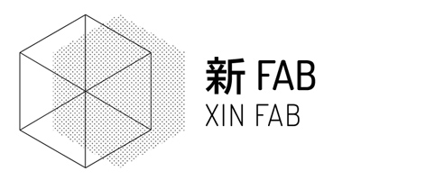 **Machine room   
 SAFETY**

**Workshop Equipment and Tools**

* Read and sign waiver
* Get membership, Xinchejian or Xinfab
* Get instructions from Xinfab staff or member
* Do not operate machines or equipment until you have been properly instructed and authorized to do so by xinfab staff/member.
* Record usage of machine/tools and defects or broken parts so we can repair.
* Equipment must be cleaned after use. Any materials, tools or equipment used must be tidied away.

**Specific Safety Rules and Guidelines**

* If equipment is fitted with guards these must be used. Equipment must never be used if the safety guards have been removed.
* Eye and ears protection must be worn.
* Wear closed toe shoes and appropriate clothing. Shorts or mini dresses are not permitted.
* Do not wear loose clothing or jewelry on the work floor. It may catch and cause a serious injury.
* When using woodworking machines the dust extractor and face masks must be used.
* Service records of all machine tools, plant and equipment must be kept. They must list the date of any service/repair and name of the person responsible for carrying out that service/repair. Faults which cannot be repaired immediately should be reported to the technician-in-charge and a note should be attached to the machine where it is clearly visible indicating that the equipment is out of order.
* No welding may be undertaken unless the technician-in-charge is satisfied that the person is capable of doing so safely. During any welding operation the fume extraction system must be used.
* Precision measuring equipment, drills, etc. must be replaced in their appropriate places after each working day.
* Tools and equipment must not be removed from the workshop without permission from the Xinfab staff/member-in-charge.
* Eating and drinking in the workshop areas are strictly prohibited.
* The area in and around the workshop must be kept clear. Any oil spillage, grease etc. must be cleaned up immediately.Do not carry loads such that the weight may be dangerous or vision obscured. In case of sickness or injury, no matter how slight, report at once to Xinfab staff. In no case should someone treat his own or someone else’s injuries or attempt to remove foreign particles from the eye.
* In case of injury resulting in possible fracture to legs, back, or neck, or any accident resulting in an unconscious condition, or a severe head injury, the user is not to be moved until medical attention has been given by authorized personnel.
* Never distract the attention of someone else, as you might cause him or her to be injured. If necessary to get the attention of someone using the machine, wait until it can be done safely.
* Stack materials, skids, bins, boxes, or other equipment so as not to block aisles, exits, firefighting equipment, electric lighting or power panel, valves, etc. FIRE DOORS AND AISLES MUST BE KEPT CLEAR.
* Do not block access to fire extinguishers.
* Report any UNSAFE condition or acts to Xinfab staff.
* Lift properly – use your legs, not your back. For heavier loads, ask for assistance.
* Do not adjust moving machinery, ask Xinfab staff to do this.
* Shut down your machine before cleaning or leaving the work area.
* Clean up any spills immediately.
* Place trash and paper in proper containers.

HAPPY MAKING!!